N0 6

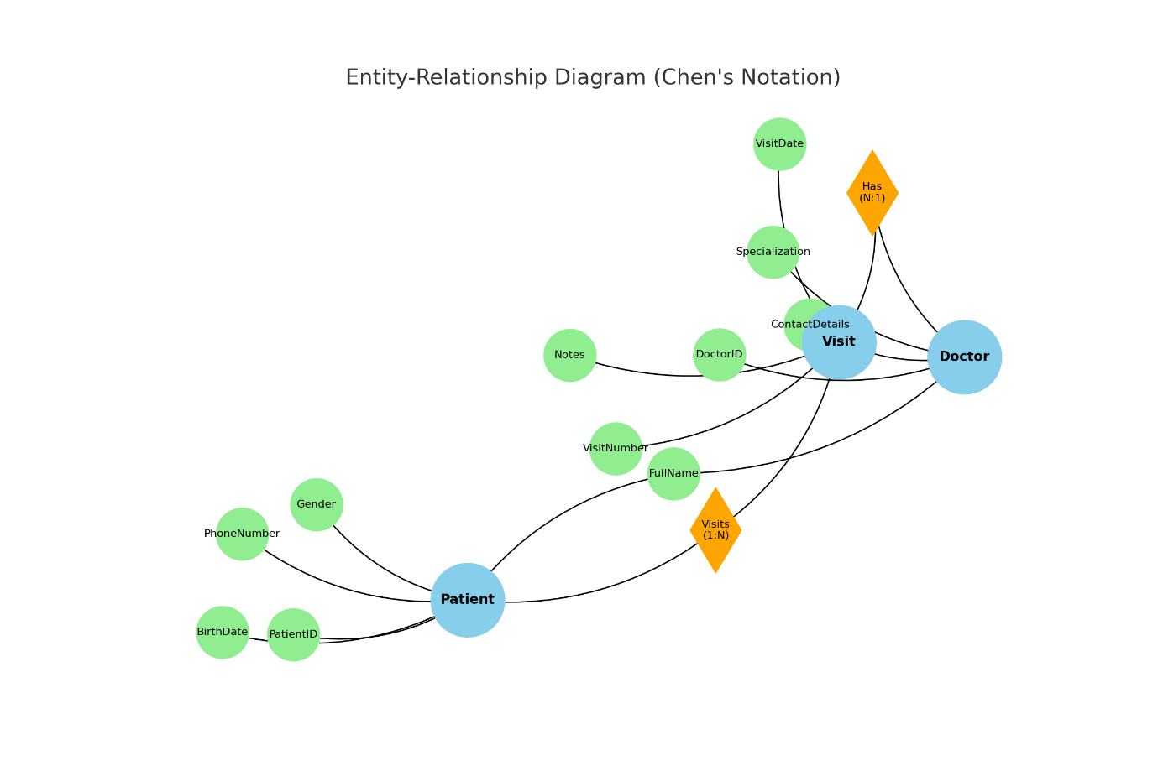

**Entity-Relationship Diagram (ERD)**, represented here using Chen's Notation, visually illustrates how three primary entities—**Patient**, **Doctor**, and **Visit**—are interconnected within a system. This diagram uses specific symbols and shapes to represent entities, their attributes, and the relationships between them.

**Entities and Their Attributes**

**Patient**

The **Patient** entity is represented by a blue ellipse.

It includes several attributes, which are shown as green circles:

**PatientID**: A unique identifier for each patient.

**FullName**: The patient's full name.

**BirthDate**: The patient’s date of birth.

**Gender**: The patient’s gender.

**PhoneNumber**: The patient’s contact number.

**Doctor**

The **Doctor** entity also has attributes:

**DoctorID**: A unique identifier for each doctor.

**FullName**: The doctor’s full name.

**Specialization**: The doctor’s area of expertise.

**ContactDetails**: How to reach the doctor.

**Visit**

The **Visit** entity captures details about medical appointments or interactions and has the following attributes:

**VisitNumber**: A unique identifier for each visit.

**VisitDate**: The date when the visit occurred.

**Notes**: Additional information or remarks about the visit.

**Relationships and Cardinalities**

**Visits**:

This relationship connects the **Patient** and **Visit** entities.

The cardinality is **1:N** (one-to-many), which means a single patient can have multiple visits.

**Has**:

This relationship links the **Visit** entity to the **Doctor** entity.

The cardinality is **N:1** (many-to-one), signifying that each visit involves a single doctor, while a doctor can oversee multiple visits.

**Understanding the Diagram**

The ERD can be read by following the relationships between entities:

A **Patient** is associated with one or more **Visits** through the **Visits** relationship. Attributes such as **VisitDate** and **Notes** provide further details about each visit.

Each **Visit** is linked to a single **Doctor** via the **Has** relationship, with attributes like **Specialization** and **ContactDetails** offering additional information about the doctor